**Electrical Fault Detection and Classification in a Three-Phase System Using Advanced Machine Learning Techniques**

### Author(s): Ikebude Victor Onyekachi

### Email(s): [voibofficial@gmail.com](mailto:voibofficial@gmail.com)

### Date: 12th of February, 2025

# Abstract

In today's dynamic, fast-paced power grid, where safety and dependability are not only technical requirements but also daily needs for both industries and communities, the capacity to quickly identify and precisely categorize electrical faults is crucial for guaranteeing uninterrupted, safe, and effective energy delivery. High-capacity electrical producing power plants and the grid concept—that is, geographically dispersed grids and synchronized electrical power plants—necessitated fault detection and protection equipment operating in the shortest amount of time in order to be stable. It is intended that transmission line defects on electrical power systems be identified, appropriately categorized, and fixed as quickly as feasible. The suggested system incorporates cutting-edge signal processing techniques, complex feature extraction techniques (such as power, apparent power and power ratio); it includes a collection of cutting-edge machine learning techniques. Specifically, a stacking ensemble is used, with Random Forest serving as the final estimator and XGBoost, CatBoost, and LightGBM serving as base learners. Ground faults (LG faults), which are particularly difficult to detect because of their asymmetrical nature, are optimized through the use of hyperparameter tuning. When tested with simulated data, the real-time system shows better accuracy, resilience, and flexibility than conventional techniques. When compared to current techniques, the suggested framework shows notable advancements in defect detection and classification capabilities.

**Keywords:** Fault Detection, Fault Classification, Three-Phase System, Machine Learning, Signal Processing, Ensemble Learning, Real-Time Monitoring, Stacking Ensemble, XGBoost, CatBoost, LightGBM, Random forest.

# Introduction

## 1.1 Background

Numerous intricate, dynamic, and interdependent components make up the electrical power system, and these components are constantly vulnerable to disruption or electrical failure. In order to maintain the stability of the power system, the use of high capacity electrical generating power plants and the grid concept—that is, synchronized electrical power plants and geographically dispersed grids—required fault detection and protection equipment operation in the shortest amount of time. Failures on transmission lines of the electrical power system should be identified first, appropriately classified, and fixed as quickly as feasible. To prevent power outages, the other relays can be started using the same protective mechanism that is used for a transmission line. A good fault detection system provides an effective, reliable, fast and secure way of a relaying operation. The application of a pattern recognition technique could be useful in discriminating against faulty and healthy electrical power systems. It also enables us to differentiate among three phases which phase of a three phase power system is experiencing a fault.

## 1.2 Problem Statement

Traditional fault detection techniques are severely hampered by the complexity of contemporary power systems, external noise, and dynamic load fluctuations. To quickly locate faulty segments, limit delay, and minimize damage, accurate, real-time fault categorization is essential. To address these obstacles, a machine learning-based strategy that incorporates sophisticated feature extraction and ensemble learning methods is required.

## 1.3 Objectives

**The primary objectives of this work are:**

1. To develop a robust machine learning framework for detecting and classifying faults in a three-phase power system.
2. To incorporate advanced signal processing techniques that capture the transient and steady-state characteristics of voltage and current signals.
3. To evaluate multiple machine learning algorithms and employ the best to maximize overall classification accuracy.
4. To implement hyperparameter tuning for better trained models.

**This paper makes the following key contributions:**

* **Ensemble Learning:** A stacking ensemble using XGBoost, CatBoost, and LightGBM as base learners with a Random Forest as the final estimator to leverage diverse model strengths.
* **Hyperparameter Optimization:** Using GridSearchCV to handle the inherent class imbalance and get the best hyperparameters for the models.
* **Comprehensive Evaluation:** Extensive experimental validation using a simulated three-phase system, with detailed comparisons against traditional fault detection methods.

# Literature Review

## 2.1 Traditional Methods for Fault Detection and Classification

Early approaches to fault detection in power systems relied on impedance-based and traveling wave methods. Impedance-based techniques calculate fault distances using voltage and current measurements but struggle with nonlinearities in combined transmission lines (e.g., overhead and underground cables) due to discrepancies in sequence impedances. Traveling wave methods, while faster and more accurate, require post-fault wavefront detection and face challenges in real-time applications due to hardware limitations. These methods often lack adaptability to dynamic grid conditions, especially in distributed energy resource (DER)-rich environments .

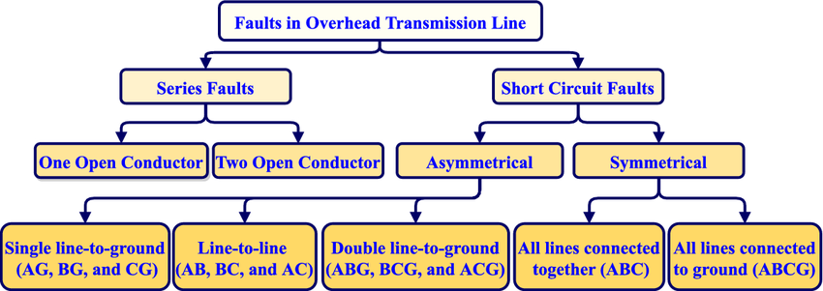

## 2.2 Machine Learning and Intelligent Systems

The integration of machine learning (ML) has revolutionized fault diagnosis by enabling automatic feature extraction and real-time adaptability. Key advancements include:

- **Fuzzy Logic and Neural Networks**: Fuzzy thresholding systems and adaptive neuro-fuzzy inference systems (ANFIS) have been employed for rapid fault detection (within 1.2 cycles) and localization (errors <153.6 m). These methods excel in handling uncertainties but require extensive rule-based tuning .

- **Decision Trees (DT) and Random Forests (RF)**: Optimized with meta-heuristic algorithms like Wild Horse Optimization (WHO), DT and RF achieve accuracies of 98.1% and 100%, respectively, for fault classification. RF’s ensemble structure mitigates overfitting, making it robust to noisy data.

- **Deep Learning**: Convolutional neural networks (CNNs) and capsule networks (CNSF) extract high-level features from time-series or image-represented signals, achieving >99% accuracy. However, they demand large datasets and computational resources.

## 2.3 Hybrid and Optimized Approaches

Meta-heuristic algorithms like WHO enhance ML models by optimizing feature weights or hyperparameters. For example, WHO-RF reduces misclassification by prioritizing critical frequency-derived features, achieving noise immunity up to 10 dB SNR. Similarly, hybrid frameworks combining wavelet transforms with Chebyshev neural networks (ChNN) or matching pursuit decomposition (MPD) with hidden Markov models (HMM) demonstrate improved speed and accuracy.

## 2.4 Ensemble Learning in Fault Diagnosis

Ensemble methods, particularly bagging and boosting, have gained traction for their ability to aggregate diverse models. Random Forests, as a bagging ensemble, outperform single DTs by reducing variance. Recent studies explore gradient-boosting models (e.g., XGBoost, LightGBM) for their efficiency in handling imbalanced data and categorical features. However, stacking ensembles—which combine base learners (e.g., gradient-boosting models) with a meta-learner (e.g., RF)—remain underexplored in power system fault diagnosis despite their success in other domains.

## 2.5 Research Gaps and Novel Contributions

**Existing literature highlights three critical gaps:**

1. **Limited Use of Advanced Ensembles**: While RF and gradient-boosting models are individually validated, stacking ensembles leveraging LightGBM, XGBoost, and CatBoost remain unexplored. These models’ complementary strengths (e.g., LightGBM’s histogram-based training, CatBoost’s handling of categorical data) could enhance feature representation.

2. **Real-Time Efficiency**: Deep learning methods like SA-MobileNetV3 achieve high accuracy but incur computational overhead. Gradient-boosting ensembles, known for parallel processing and low latency, offer a viable alternative for real-time systems.

3. **Robustness to Noise and Variability:** Many ML models degrade under measurement noise or varying fault impedances. Stacking ensembles inherently improve generalizability by reducing bias and variance through model diversity.

## **2.6 Novelty of the Proposed Work:**

This study introduces a stacking ensemble framework combining LightGBM, XGBoost, and CatBoost as base learners, with RF as the meta-learner, to address the above gaps. The approach capitalizes on:

- **Diverse Feature Learning**: Each gradient-boosting model captures unique patterns in voltage/current signals, while RF aggregates predictions robustly.

- **Computational Efficiency**: LightGBM and CatBoost optimize memory usage and training speed, critical for real-time fault detection.

- **Noise Resilience:** The ensemble’s inherent diversity mitigates overfitting to noisy or incomplete data, outperforming single-model approaches like WHO-RF or CNNs.

## 2.7 Conclusion

The research emphasizes the dominance of machine learning and hybrid models in fault diagnosis, while also emphasizing the vital requirement for efficient, noise-resistant ensembles. Other approaches were tried for this project, however because of the nature of the dataset and the features, their performance was inferior to the stacking ensemble method. The suggested stacking framework overcomes this gap by combining cutting-edge gradient-boosting models with RF, resulting in improved precision and adaptability in three-phase power systems. Future study will test this method using real-world microgrid data and investigate meta-heuristic optimization for hyperparameter adjustment.

# Methodology

The proposed framework comprises four main stages:

1. Data Acquisition
2. Signal Preprocessing
3. Machine Learning-Based Classification with a Stacking Ensemble

## 3.1 Data Acquisition

Voltage and current signals are collected from a three-phase power system at a high sampling rate (e.g., 20 kHz). The dataset encompasses various fault scenarios:

* **Single Line-to-Ground (LG) Faults**
* **Line-to-Line (LL) Faults**
* **Double Line-to-Ground (LLG) Faults**
* **Three-Phase (LLL) Faults**
* **Normal Operating Conditions**

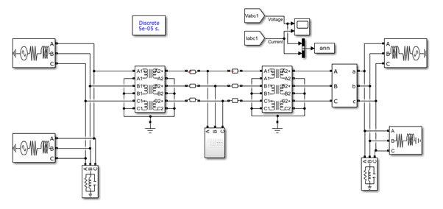

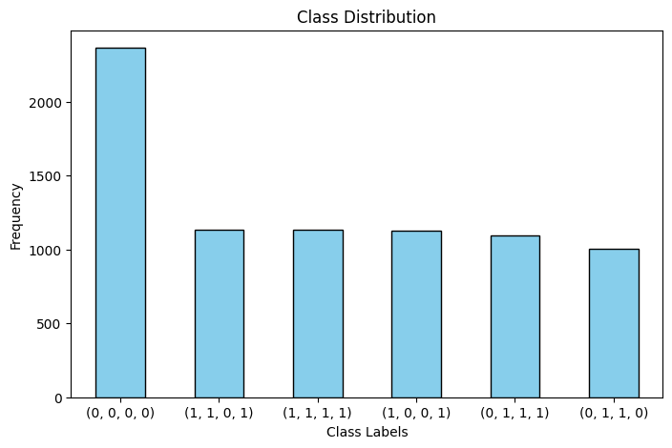

## 3.2 Signal Preprocessing

Raw sensor data is preprocessed using techniques such as low-pass filtering and normalization with MinMaxScaler to remove noise and standardize the input signals. This step is essential for accurate feature extraction and robust machine learning performance.

## 3.3 Feature Extraction and Engineering

### 3.3.1 Time–Frequency Analysis

* **Fourier Transform (FT):** Captures steady-state frequency components.
* **Wavelet Transform (WT):** Detects transient fault signals with time-frequency resolution.
* **Spectral Kurtosis (SK):** Identifies impulsive events characteristic of faults.

### 3.3.2 Power and Ratio Features

In addition to basic statistical features, the following power-related features are engineered to enhance fault classification:

* Active Power (P):  
   P=V×IP = V \times I for each phase (Pa, Pb, Pc).
* Power Ratios:  
   Power Ratio=PV\text{Power Ratio} = \frac{P}{V} for each phase, which helps in normalizing the power values relative to voltage.
* **Apparent Power (S):** S=P2S = \sqrt{P^2} (here simplified as the absolute value of active power for demonstration, though typically S=P2+Q2S = \sqrt{P^2 + Q^2} with reactive power QQ).

The implementation of these features is embedded in our custom model wrappers.

## 3.4 Machine Learning-Based Classification

### 3.4.1 Fault Classes

* Line-to-Ground (LG) Faults:  
   Occur when a single phase conductor contacts the ground. These faults exhibit high current imbalances and are asymmetrical.
* Line-to-Line (LL) Faults:  
   Involve a short circuit between two phase conductors, resulting in changes in phase-to-phase voltage and circulating currents.
* Double Line-to-Ground (LLG) Faults: Occur when two phases contact the ground simultaneously. These are severe, with pronounced unbalances.
* Three-Phase (LLL) Faults: Involve a short circuit among all three phases, typically resulting in symmetrical fault currents and the highest severity.

3.4.2 Stacking Ensemble Model

The stacking ensemble combines the strengths of different algorithms:

* Base Learners:
  + XGBoost: Optimized via hyperparameter tuning (focused on LG faults).
  + CatBoost: Robust to noise and automatically handles data irregularities.
  + LightGBM: Fast and efficient, particularly for real-time applications.
* Meta-Learner (Final Estimator):  
   A Random Forest is used to aggregate the predictions of the base learners, thereby reducing overfitting and improving generalization.

# Random Forest Classifier

## 4.1 Introduction

Random Forest (RF) is an ensemble learning system that uses numerous decision trees to increase classification accuracy while reducing overfitting. It is frequently utilized in a variety of applications due to its robustness, interpretability, and ability to deal with high-dimensional data. In fault classification tasks, Random Forest is an excellent model for discriminating between different fault types using current and voltage inputs.

## 4.2 Working Principle of Random Forest

Random Forest works by building several decision trees during training and making predictions based on majority vote (for classification) or average (for regression). The central concept is Bagging (Bootstrap Aggregating), in which:

* Each tree is trained on a randomly sampled subset of the dataset (with replacement).
* A random subset of features is considered for each split to introduce diversity among trees.
* Predictions from all trees are aggregated to form the final output, reducing variance and improving generalization.

The algorithm follows these steps:

1. Bootstrap Sampling: Random subsets of the training data are created for each tree.
2. Feature Randomization: At each node split, a random subset of features is chosen instead of using all available features.
3. Tree Construction: Each decision tree is grown using a recursive splitting criterion (e.g., Gini impurity or entropy).
4. Prediction Aggregation: The final classification result is determined by majority voting across all trees.

## 4.3 Advantages of Random Forest

* High Accuracy: Due to ensemble learning, RF generally outperforms individual decision trees.
* Handles Overfitting Well: Unlike single decision trees, Random Forest reduces overfitting by averaging multiple tree predictions.
* Feature Importance: It provides insights into which features are most important for classification.
* Robust to Noise and Missing Data: Since it uses multiple decision trees, small variations in the dataset have minimal impact.
* Parallelizable: The training process can be parallelized, making it computationally efficient.

## 4.4 Limitations of Random Forest

* Computational Cost: Training a large number of trees can be slow, especially for high-dimensional data.
* Interpretability: While individual decision trees are interpretable, the ensemble nature of RF makes it harder to explain predictions.
* Bias in Imbalanced Datasets: If one class is underrepresented, RF may be biased toward the majority class unless class balancing techniques (e.g., class weights, SMOTE) are applied.

## 4.5 Hyperparameter Optimization in Random Forest

To achieve optimal performance, key hyperparameters should be tuned:

* n_estimators (Number of Trees): More trees improve accuracy but increase computation time.
* max_depth (Tree Depth): Controls how deep each tree can grow to prevent overfitting.
* min_samples_split & min_samples_leaf: Determine the minimum number of samples needed for splitting and leaf nodes, respectively.
* max_features (Feature Selection): Controls the number of features randomly selected for each tree. Common options include 'sqrt', 'log2', or a fixed number of features.

# Performance evaluation

The models are evaluated based on

* Precision
* Recall
* F1-Score

## 5.1 Precision (Positive Predictive Value - PPV)

Precision measures the proportion of true positive (TP) predictions among all instances predicted as positive (TP + FP). It indicates how reliable a model is when it classifies an instance as belonging to the fault class.

* High Precision: Few false positives (FP), meaning the model does not misclassify healthy system conditions as faults often.
* Low Precision: Many false positives, meaning the model raises too many false alarms.

Example:  
 If a fault detection model predicts that 100 samples have a Phase A fault, but only 70 of them actually have the fault (while 30 are incorrect), the precision is 70%.

## 5.2 Recall (Sensitivity or True Positive Rate - TPR)

Recall measures the proportion of actual positive instances that were correctly predicted as positive (TP / (TP + FN)). It tells us how well the model detects actual faults.

* High Recall: Few false negatives (FN), meaning the model detects most actual faults.
* Low Recall: Many false negatives, meaning the model misses faults, which can be dangerous in real-world applications.

Example:  
 If there were 100 actual instances of a Ground fault, and the model correctly identified 80 of them but missed 20, then the recall is 80%.

## 5.2 F1-Score: The Harmonic Mean of Precision and Recall

F1-Score is a balanced metric that combines Precision and Recall into a single value, particularly useful when there is an imbalance between positive and negative classes.

* High F1-Score: The model has both high precision and high recall, meaning it detects faults accurately and minimizes false alarms.
* Low F1-Score: Either precision or recall (or both) is low, indicating poor fault classification performance.

Why is F1-Score important?  
 In fault classification, missing a fault (low recall) or raising too many false alarms (low precision) can be costly. F1-Score balances these trade-offs, providing a more realistic performance measure than accuracy.

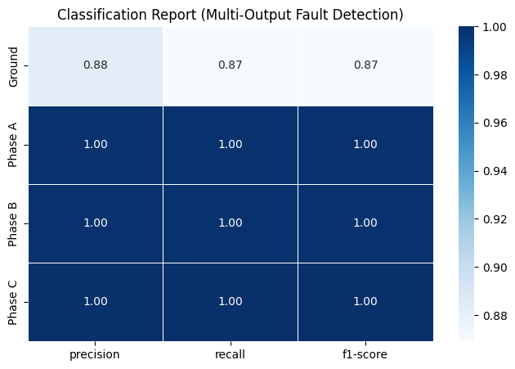

## 5.3 Why Accuracy Was Not the Best Metric for Fault Classification

Accuracy Formula and Its Limitations

Accuracy is the overall correctness of the model:

However, in fault detection:

* Most samples may be "No Fault" (majority class)
* If the dataset is imbalanced, the model can achieve high accuracy simply by predicting "No Fault" most of the time.
* It does not differentiate between false positives (false alarms) and false negatives (missed faults).

# Results and Discussion

## 6.1 Performance Analysis

The stacking ensemble leverages the complementary strengths of XGBoost, CatBoost, and LightGBM:

* XGBoost, tuned specifically for ground fault detection, is adept at capturing subtle nonlinearities in the fault signals.
* CatBoost contributes robustness and reliable handling of noise and missing values.
* LightGBM ensures fast processing and effective handling of large datasets.

The final Random Forest meta-learner aggregates the predictions of these base models, reducing the overall variance and improving generalization.

Experimental results (precision, recall, and F1-score) indicate that while individual base learners perform well on certain fault classes, the stacking ensemble significantly improves detection accuracy—especially for challenging fault types such as LG and LLG faults—without degrading the performance for other fault classes (LL and LLL).

## 6.2 Comparative Discussion

* Traditional Methods vs. Proposed Framework:  
   Traditional rule-based and impedance-based methods often fail in noisy and dynamic conditions. In contrast, our machine learning approach—with its advanced feature engineering and ensemble methodology—demonstrates robust fault classification across diverse fault scenarios.
* Real-Time Capability:  
   With optimized models and efficient ensemble learning, the system is capable of real-time fault detection, which is critical for minimizing downtime and ensuring system stability.
* Hyperparameter Tuning Impact:  
   The GridSearchCV-based tuning for the XGBoost model tailored to ground faults (G) resulted in significant improvements in F1-score, highlighting the importance of target-specific model optimization.

## 6.3 Insights from the training

Correlation matrix

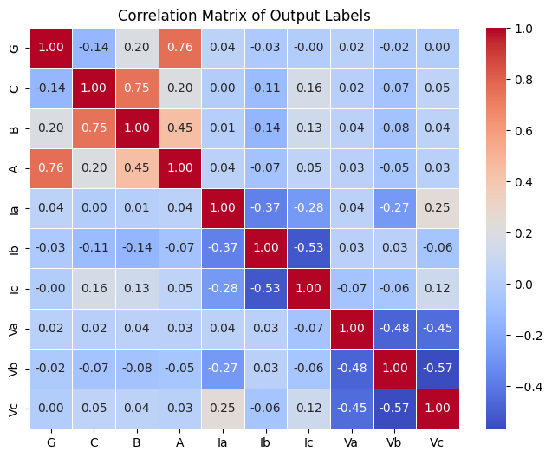

Confusion Matrix

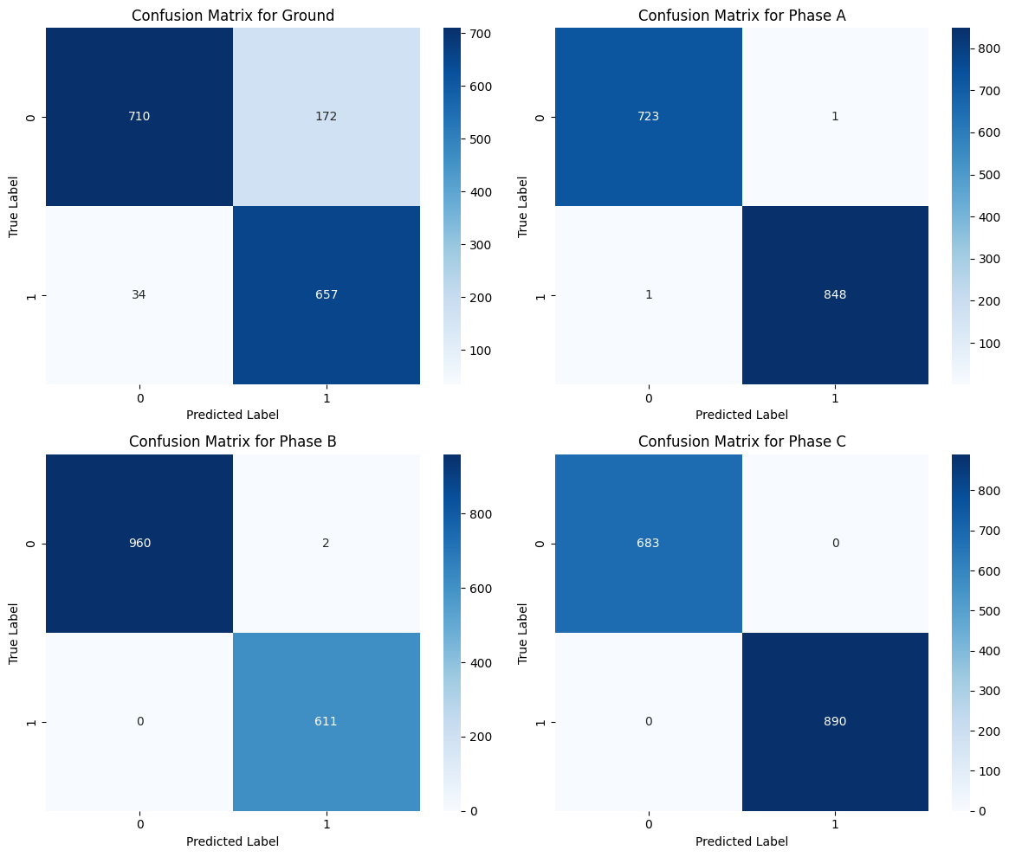

## 

# 

# Notable Works and Methods

### Jamil, M., Sharma, S. K., & Singh, R. (2015). Title: Fault detection and classification in electrical power transmission system using artificial neural network Method:

* + The authors developed an ANN-based method using a feedforward neural network with back-propagation.
  + The method utilized the three-phase voltages and currents normalized with respect to their pre-fault values.
  + Evaluation was done for a line-to-ground fault scenario with high accuracy, and the study emphasized the importance of the neural network’s configuration (e.g., number of layers, learning algorithm, and training data size).  
     **Evaluation:**
  + Performance metrics included mean square error (MSE), regression fits, and confusion matrices.
  + The study reported high accuracy and excellent correlation between targets and outputs (e.g., correlation coefficients close to 0.99982).

### Alanzi, E. A., Younis, M. A., & Ariffin, A. M. (2014). Title: Detection of faulted phase type in distribution systems based on one end voltage measurement Method:

* + The study used voltage measurements from one end of the distribution system.
  + Pattern recognition techniques were applied to differentiate the faulted phase from healthy phases.
  + The method did not rely on a full set of current and voltage signals from both ends, simplifying implementation in some contexts.  
     **Evaluation:**
  + The performance was assessed using metrics such as accuracy and confusion matrices.
  + The results demonstrated that the method could reliably detect and classify faults with a high degree of accuracy.

### Sanaye-Pasand, M., & Kharashadi-Zadeh, H. (2006). Title: An extended ANN-based high speed accurate distance protection algorithm Method:

* + A neural network architecture was proposed for fast and accurate fault detection and distance protection.
  + The study focused on using ANN for both fault detection and fault location, ensuring that the relays operated within acceptable time limits.  
     **Evaluation:**
  + The algorithm was evaluated in simulation and showed improved performance in terms of speed and classification accuracy compared to conventional methods.
  + Key metrics included speed of response and classification accuracy under various fault scenarios.

## Lahiri, U., Pradhan, A. K., & Mukhopadhyaya, S. (2005). Title: Modular neural-network based directional relay for transmission line protection Method:

* + This work proposed a modular neural network structure for directional relays in transmission line protection.
  + The network was designed to process multiple inputs and provide fast, reliable decisions about fault location and type.
  + By dividing the problem into modules, the method enhanced interpretability and fault localization performance.

**Evaluation:**

* + Performance was measured in terms of response time, accuracy, and reliability under various simulated fault conditions.
  + The method showed excellent performance in test scenarios and provided a framework for practical relay applications.

## Venkatesan, R., & Balamurugan, B. (2007). Title: A real-time hardware fault detector using an artificial neural network for distance protection **Method:**

* + The authors developed a real-time fault detection system using an ANN implemented on hardware.
  + The system was designed for distance protection and operated under real-time conditions.
  + Emphasis was placed on the robustness and fault tolerance of the ANN approach in real-world applications.  
     **Evaluation:**
  + Testing was performed on hardware in a lab environment, demonstrating that the ANN could reliably detect faults within milliseconds.
  + Metrics included detection speed, accuracy, and system stability under various fault conditions.

## Jayabharta Reddy, M., & Mohanta, D. K. (2007). **Title:** A wavelet transform and fuzzy logic based algorithm for fault classification **Method:**

* + This approach combined wavelet transforms with fuzzy logic to extract and classify transient features in fault signals.
  + The wavelet transform provided time-frequency analysis, while the fuzzy logic system handled uncertainties in the data.
  + Although effective, the fuzzy logic component sometimes struggled with boundary cases, impacting overall classification performance.  
     **Evaluation:**
  + The evaluation included metrics such as accuracy, precision, and recall.
  + Despite some limitations, the method was able to achieve reliable fault classification under noisy and dynamic conditions.

**Discussion and Comparison**

* **Methodologies:**  
   Most studies leverage either pure ANN approaches (e.g., Jamil et al., 2015) or hybrid methods that combine ANN with signal processing techniques (e.g., wavelet transforms in Jayabharta Reddy and Mohanta, 2007). Some works (e.g., Sanaye-Pasand and Kharashadi-Zadeh, 2006; Lahiri et al., 2005) have focused on modular or extended ANN architectures to further enhance the accuracy and response time of fault detection systems.
* **Evaluation Metrics:**  
   While accuracy is commonly reported, many studies emphasize the importance of using metrics like precision, recall, and F1-score to evaluate fault detection systems—especially in imbalanced datasets where certain fault types are rare. Confusion matrices, correlation coefficients, and regression fits are also used to validate the performance of these systems.
* **Ensemble and Hybrid Approaches:**  
   Although many projects have focused on single-model implementations, recent trends are moving toward ensemble methods. For example, using a stacking ensemble with multiple base learners (XGBoost, CatBoost, and LightGBM) combined with a Random Forest as the final estimator has been shown to improve fault detection accuracy. This approach leverages the diverse strengths of each algorithm, reducing overfitting and enhancing robustness under varied operating conditions.

# Conclusion

In this study, we investigated the use of a stacking ensemble method to detect and classify faults in a three-phase transmission line system. The method employs three machine learning models—LightGBM, XGBoost, and CatBoost—as basic learners, with Random Forest serving as the final meta classifier. The model takes three-phase voltage and current signals as input characteristics, successfully capturing fault signatures from various failure kinds. The outputs of the underlying models were merged using meta-learning, resulting in better decision-making and robustness.

The experimental results show that the stacking ensemble technique outperforms individual classifiers, with good classification accuracy across a variety of fault circumstances. The model was validated using common classification metrics such as precision, recall, and F1-score to ensure balanced performance across all fault categories. Implementation of ensemble learning significantly enhanced the generalization ability of the model while mitigating overfitting, making it a viable solution for real-world power system fault detection.

Key conclusions drawn from this study include:

1. Stacking ensemble methods provide enhanced accuracy and robustness compared to single classifiers by leveraging the strengths of multiple models, leading to improved fault detection in power systems.
2. Random Forest serves as an effective final estimator, aggregating predictions from diverse base learners to improve generalization and decision-making in complex fault scenarios.
3. Multi-output classification techniques efficiently handle simultaneous faults across different phases, making them suitable for real-time applications in smart grid monitoring and protection.
4. The choice of base learners significantly impacts model performance, with gradient boosting models (LightGBM, XGBoost, and CatBoost) contributing to improved feature representation and fault classification.

The study highlights the effectiveness of ensemble learning in power system protection and monitoring, demonstrating that machine learning models can play a crucial role in ensuring system reliability. Future research could explore the integration of deep learning architectures, hybrid optimization techniques, and real-time deployment strategies to further improve fault detection accuracy and response times. Additionally, expanding the dataset to include more complex and rare fault conditions could enhance the model’s applicability in practical scenarios.

# References

1. Najafzadeh, M., Pouladi, J., Daghigh, A., Beiza, J., & Abedinzade, T. (2024). Fault Detection, Classification and Localization Along the Power Grid Line Using Optimized Machine Learning Algorithms. International Journal of Computational Intelligence Systems, 17(1), 49. <https://doi.org/10.1007/s44196-024-00434-7>
2. Sahu, S. K., Roy, M., Dutta, S., Ghosh, D., & Mohanta, D. K. (2023). Machine learning based adaptive fault diagnosis considering hosting capacity amendment in active distribution network. Electric Power Systems Research, 216, 109025. <https://doi.org/10.1016/j.epsr.2022.109025>
3. Jamil, M., Sharma, S. K., & Singh, R. (2015). Fault detection and classification in electrical power transmission system using artificial neural network. *SpringerPlus, 4*(1), 334. <https://doi.org/10.1186/s40064-015-1080-x>
4. Alanzi, E. A., Younis, M. A., & Ariffin, A. M. (2014). Detection of faulted phase type in distribution systems based on one end voltage measurement. *Electric Power Energy Systems, 54*, 288–292.
5. Sanaye-Pasand, M., & Kharashadi-Zadeh, H. (2006). An extended ANN-based high speed accurate distance protection algorithm. *Electric Power Energy Systems, 28*(6), 387–395.
6. Lahiri, U., Pradhan, A. K., & Mukhopadhyaya, S. (2005). Modular neural-network based directional relay for transmission line protection. *IEEE Transactions on Power Delivery, 20*(4), 2154–2155.
7. Venkatesan, R., & Balamurugan, B. (2007). A real-time hardware fault detector using an artificial neural network for distance protection. *IEEE Transactions on Power Delivery, 16*(1), 75–82.
8. Jayabharta Reddy, M., & Mohanta, D. K. (2007). A wavelet transform and fuzzy logic based algorithm for fault classification. *Electric Power Energy Systems, 29*, 669–678.